|  |  |  |
| --- | --- | --- |
| SCHOOL OF INFORMATION AND TECHNOLOGY | | |
| NAME: ELEC, Ralph Luis G.  TALUSIG, Nikos A. | DATE PERFORMED: 11/28/2024 | /50 |
| Section:IDC2 | DATE SUBMITTED: 12/03/2024 |

# SYSADM1 – Capacity Management & Planning

## Part 1. A Simulated Dataset for Capacity Planning Exercise

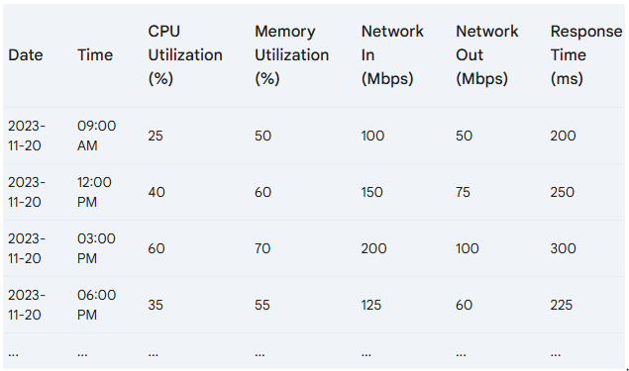**Scenario:** A mid-sized e-commerce website is expecting a significant surge in traffic due to an upcoming holiday sale.

### Projected Traffic Increase

* **Expected Peak Traffic:** 5x the normal peak traffic
* **Peak Time:** 12:00 PM - 3:00 PM on the sale day

### System Specifications

* **Server Count:** 5
* **CPU Cores per Server:** 8
* **RAM per Server:** 32GB
* **Network Bandwidth per Server:** 1Gbps

### Additional Considerations

* **New Product Launch:** A highly anticipated product will be released during the sale.
* **Marketing Campaign:** A major marketing campaign will be launched to promote the sale.
* **Potential Cyber Threats:** Increased traffic can attract malicious actors.

Tasks:

1. Review the provided server performance data and identify potential bottlenecks
2. Brainstorm possible solutions to address the identified bottlenecks. Propose potential solutions considering hardware and software-based solutions.
3. Discuss the pros and cons of each proposed solution by filling out the table below.

|  |  |  |  |  |  |  |
| --- | --- | --- | --- | --- | --- | --- |
| Proposed Solution | |  |  | | --- | --- | | Pros | Cons | | Cost | Complexity | Potential impact on system performance |

Grading Rubric:

|  |  |  |  |
| --- | --- | --- | --- |
| Criteria | Excellent | 10pts | Good | 7pts | Needs Improvement | 4pts |
| **Problem Identification** | Accurately identifies the primary problem and provides a detailed explanation. | Identifies the main problem and provides a basic explanation. | Identifies a problem but lacks clarity or accuracy. |
| **Solution Proposal** | Proposes multiple relevant solutions and provides detailed explanations, including potential drawbacks and benefits. | Proposes one or two relevant solutions but lacks detailed explanation. | Proposes a solution but lacks feasibility or relevance. |
| **Evaluation of Solutions** | Provides a thorough evaluation of the proposed solutions, considering factors like cost, complexity, and potential impact. | Provides a basic evaluation of the proposed solutions, but lacks depth. | Does not evaluate the proposed solutions or provides a superficial evaluation. |
| Score: | | | /30 |

**Part 2. Network Scalability Analysis**

Recall the e-commerce website scenario we discussed earlier. Given the expected surge in traffic, analyze the provided network topology diagram. Identify potential bottlenecks and areas where scalability might be a concern. Propose specific strategies to improve the network's scalability and performance to ensure a seamless user experience during the peak traffic period. Consider factors such as increased user demand, new applications, and security threats.

**IMPROVED NETWORK:**

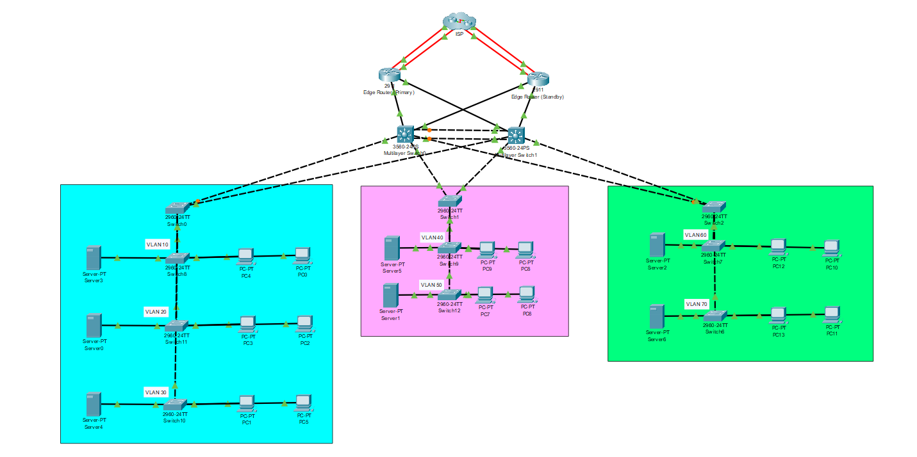  
In the improved topology, key potential bottlenecks include the dependence on the 3560 Multilayer Switch and Edge Routers for inter-VLAN and internet-bound traffic, as these components centralize data flow. While redundancy has been introduced via the primary and standby edge routers, the connections between the VLAN-specific switches (e.g., VLAN 10, VLAN 20, etc.) and the core devices may experience congestion during peak usage due to the limited uplink bandwidth. Furthermore, security risks such as unauthorized access or VLAN hopping persist without robust configurations like Access Control Lists (ACLs) and port-based security.   
  
To ensure scalability and optimal performance, it is recommended to upgrade the core switches to higher-capacity devices supporting multi-gigabit links and implement Link Aggregation Protocol (LACP) for increased bandwidth on uplinks. Introducing software-defined networking (SDN) can enhance traffic management and resource allocation dynamically. Additionally, inter-VLAN routing can be improved by enabling Layer 3 routing capabilities on all distribution switches, reducing the dependency on the core for routing. While these upgrades might increase initial costs, the benefits include better fault tolerance, reduced congestion, and improved security—essential for supporting growing user demands and new applications in the network.

|  |  |  |  |
| --- | --- | --- | --- |
| Criteria | Excellent | 10pts | Good | 7pts | Needs Improvement | 4pts |
| **Network Analysis** | Accurately identifies potential bottlenecks, security risks, and capacity limitations. | Identifies key network components and some potential bottlenecks. | Identifies some basic network components but lacks a comprehensive analysis. |
| **Scalability Planning** | Proposes multiple relevant solutions and provides detailed explanations, including potential drawbacks and benefits. | Proposes some relevant scalability strategies but lacks detail. | Proposes limited scalability strategies. |
| **Evaluation of Solutions** | Proposes comprehensive scalability strategies, including specific recommendations for hardware upgrades, software configurations, and network optimizations. | Provides a basic evaluation of the proposed solutions, but lacks depth. | Does not evaluate the proposed solutions or provides a superficial evaluation. |
| **Proposed Design** | Provides a detailed and well-justified design, including network diagrams, configuration details, and implementation plans. | Provides a basic design but lacks specific details and justifications. | Does not provide a clear and detailed design. |
| **Evaluation and Justification** | Provides a thorough evaluation of the proposed solutions, considering factors like cost, complexity, and potential impact. | Provides a basic evaluation of the proposed solutions, but lacks depth. | Does not evaluate the proposed solutions or provides a superficial evaluation |
| Score: | | | /50 |